

Traces NT

Multi Factor Authentication (MFA).

Register your mobile phone on Traces.

Log into Traces

https://webgate.ec.europa.eu/tracesnt/login

In the top right corner click on your email, in the dropdown, select “Edit your profile”.

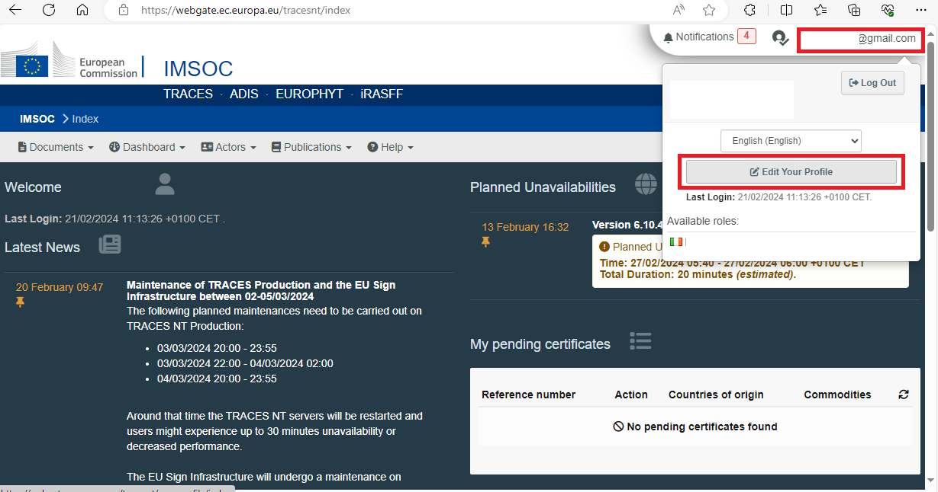

In “Edit your profile”, click on “My account on EU Login”.

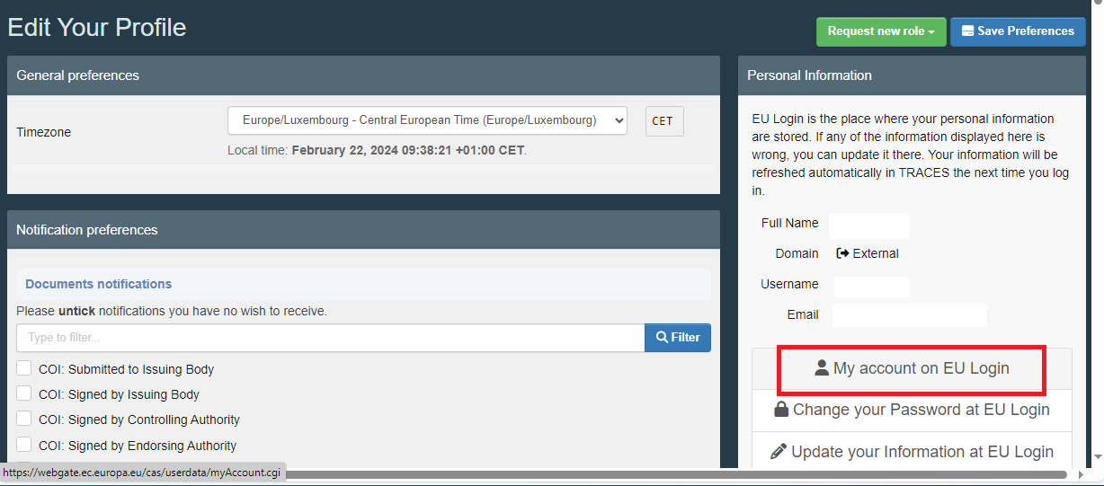

In “My Account”, click on “Manage my mobile devices”.

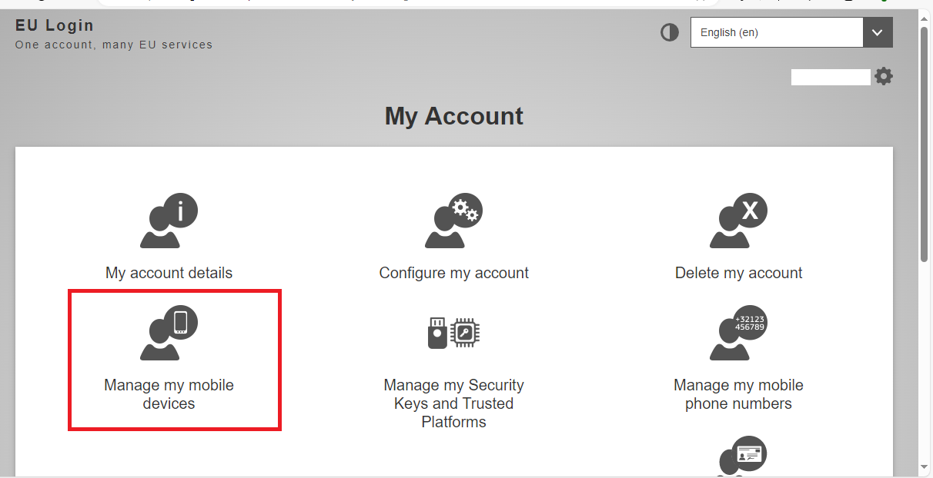

In “Manage my mobile devices” click on “Add a mobile device”.

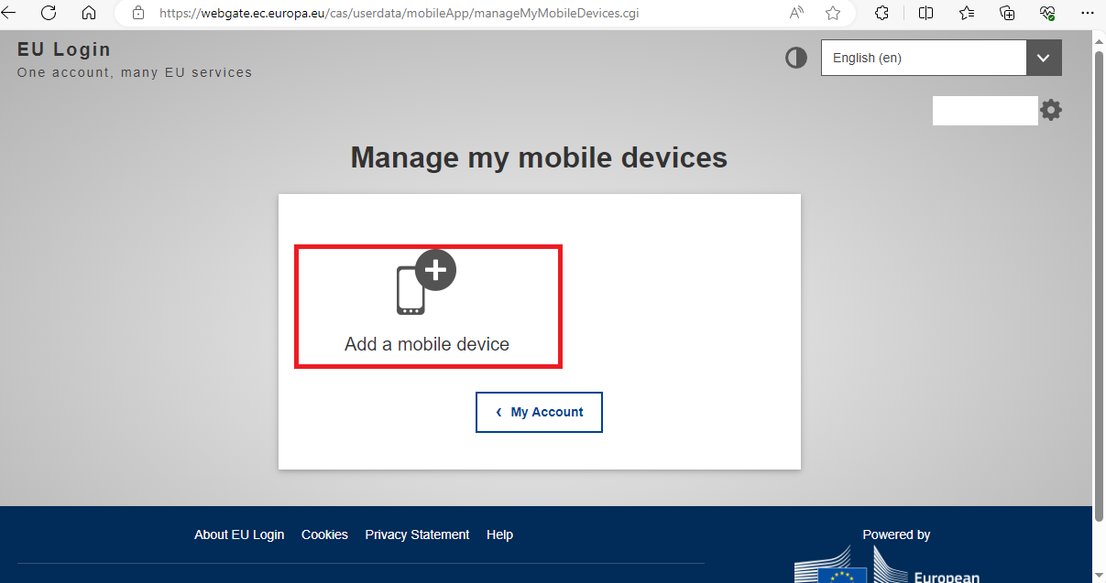

Enter a name for your mobile device.

Create a 4-digit pin number, confirm the 4-digit pin number, and then click “Submit”.

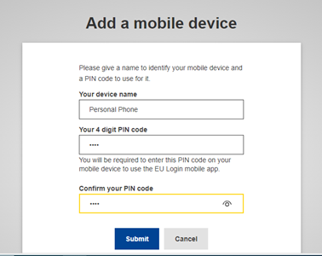

You must download the EU Login App to your mobile device to authenticate your phone number.

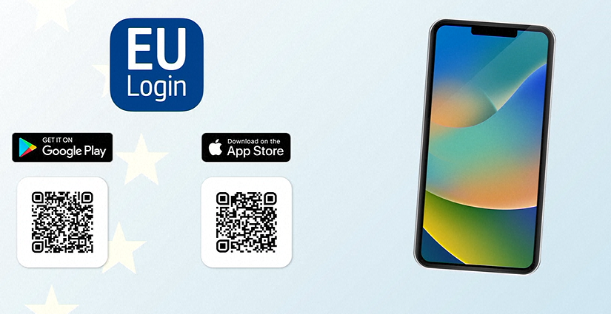

Download the EU Login app on your phone/tablet, open it, you must allow Authorisations.

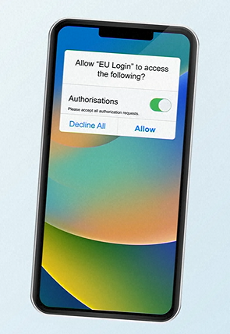

Tap on “Initialise”, then tap on “Continue”.

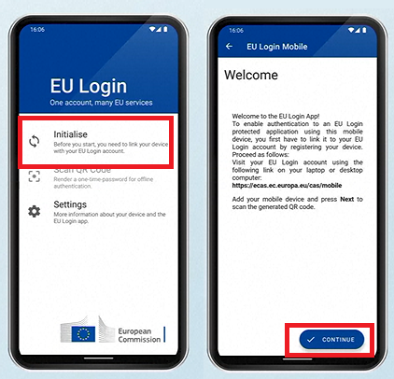

Scan the QR code displayed on your pc/laptop screen with the EU login phone app.

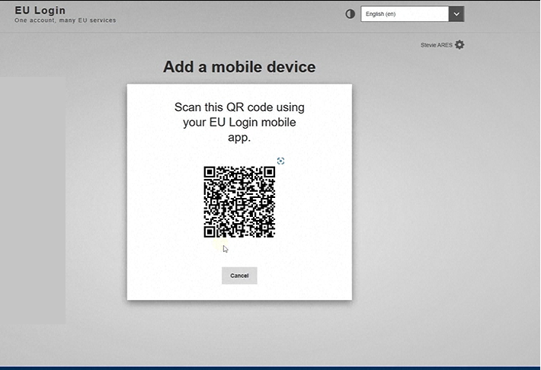

Enter the pin code you created for your mobile device.

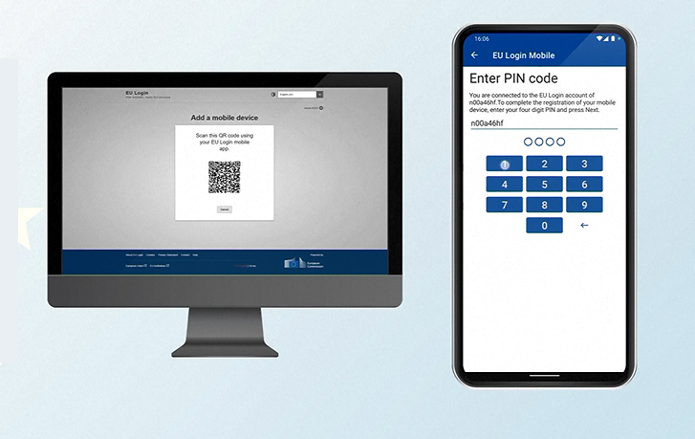

You will get confirmation, “A device has been added”.

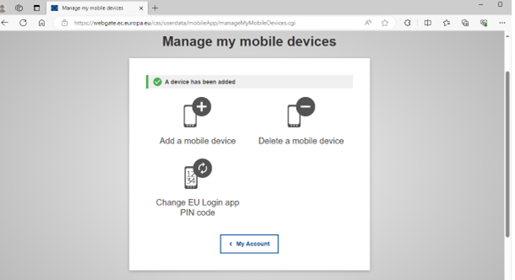

You have successfully added and verified your mobile device.

